## Exercice 1 : Manipulation des pointeurs

Soient trois entiers a, b et c et deux pointeurs de type entier p1 et p2.

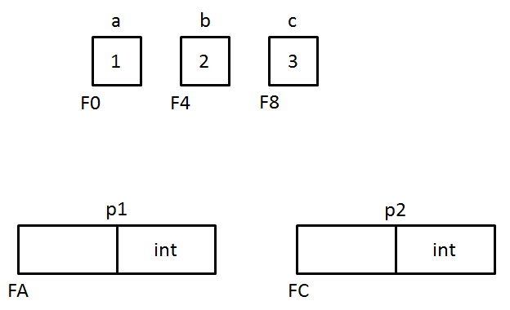

1. Déterminez quelle est la valeur des différents éléments donnés dans le tableau pour chaque opération.

|  |  |  |  |  |  |  |  |  |  |  |
| --- | --- | --- | --- | --- | --- | --- | --- | --- | --- | --- |
|  | **a** | **b** | **c** | **&a** | **&b** | **&c** | **p1** | **p2** | **\*p1** | **\*p2** |
| **Initialisation** |  |  |  |  |  |  |  |  |  |  |
| **p1 = &a** |  |  |  |  |  |  |  |  |  |  |
| **p2 = &c** |  |  |  |  |  |  |  |  |  |  |
| **\*p1 = *p2** |  |  |  |  |  |  |  |  |  |  |
| **(*p2)++** |  |  |  |  |  |  |  |  |  |  |
| **p1 = p2** |  |  |  |  |  |  |  |  |  |  |
| **p2 = &b** |  |  |  |  |  |  |  |  |  |  |
| **\*p2 = *p1 – 2 * *p2** |  |  |  |  |  |  |  |  |  |  |
| **(*p2)--** |  |  |  |  |  |  |  |  |  |  |
| **\*p1 = *p2 - c** |  |  |  |  |  |  |  |  |  |  |
| **a = (2 + *p2) * *p1** |  |  |  |  |  |  |  |  |  |  |
|  | **a** | **b** | **c** | **&a** | **&b** | **&c** | **p1** | **p2** | **\*p1** | **\*p2** |
| **p2 = &c** |  |  |  |  |  |  |  |  |  |  |
| **\*p2 = *p1 / *p2** |  |  |  |  |  |  |  |  |  |  |
| **\*p1 = a + b** |  |  |  |  |  |  |  |  |  |  |
| **a += *p1** |  |  |  |  |  |  |  |  |  |  |
| **b = *p1 + *p2** |  |  |  |  |  |  |  |  |  |  |
| **\*p1 = 2 * a** |  |  |  |  |  |  |  |  |  |  |
| **a = *p2** |  |  |  |  |  |  |  |  |  |  |
| **\*p2 = *p1 - *p2** |  |  |  |  |  |  |  |  |  |  |
| **\*p1 = 1 – c** |  |  |  |  |  |  |  |  |  |  |
| **\*p2 += *p1 + a** |  |  |  |  |  |  |  |  |  |  |
| **p2 = p1 = &a** |  |  |  |  |  |  |  |  |  |  |
| **p2++** |  |  |  |  |  |  |  |  |  |  |
| **p1 += 2** |  |  |  |  |  |  |  |  |  |  |
| **c = p2 == &c** |  |  |  |  |  |  |  |  |  |  |
| **p1 = NULL** |  |  |  |  |  |  |  |  |  |  |

1. Vérifiez que vos réponses sont correctes à partir du fichier *mainPointeur.c* et du débogueur.